LAB ACTIVITY 2:

Introduction to Basic Operations in Python

**Learning Outcomes:**

By the end of this laboratory session, you should be able to:

1. Construct Python variables correctly
2. Manipulate Python literals using converting operation

**Hardware/Software:** Computer, Phyton 3.5 or above.

**Activity 2A**

Activity Outcome**:** Construct Python variables correctly.

Procedure:

**Step 1:** Open Code editor and type the following code:

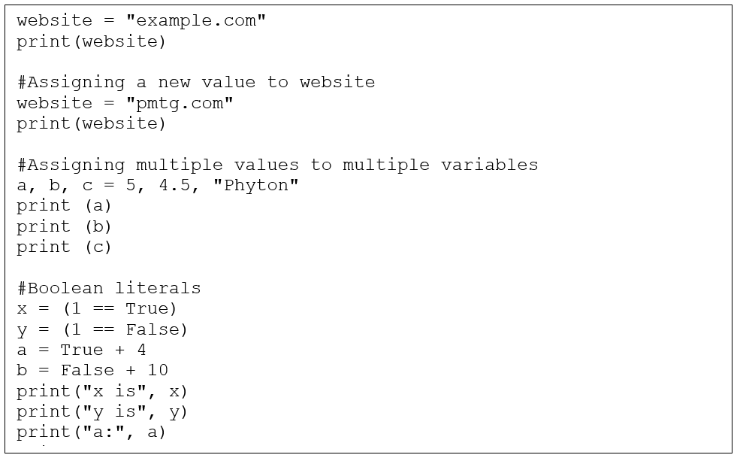print("b:", b)

**Step 2:** Save, compile, and run the program. Save the program as Act2A.py. Write the output in the area below.

**Output:**

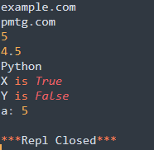

**Activity 2B**

Activity Outcome: Construct input() functions

Procedure:

**Step 1:** Open code editor and type the following code:

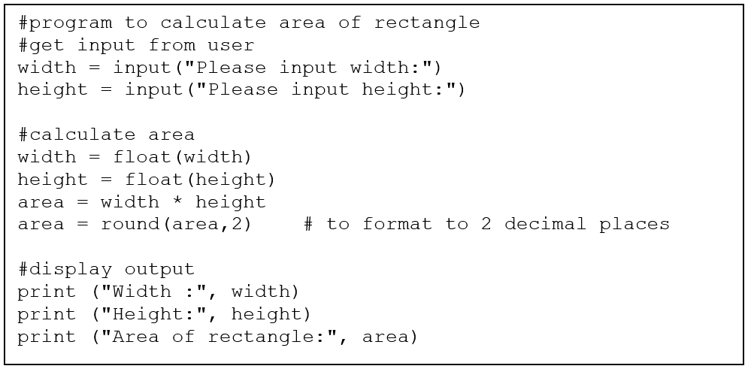

**Step 2:** Save, compile and run the program. Save the program as Act2B.py. Write the output in the area below.

**Output:**

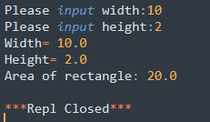

**Activity 2C**

Activity Outcome : String formatting.

Procedures:

**Step 1:** Open code editor and type the following code:

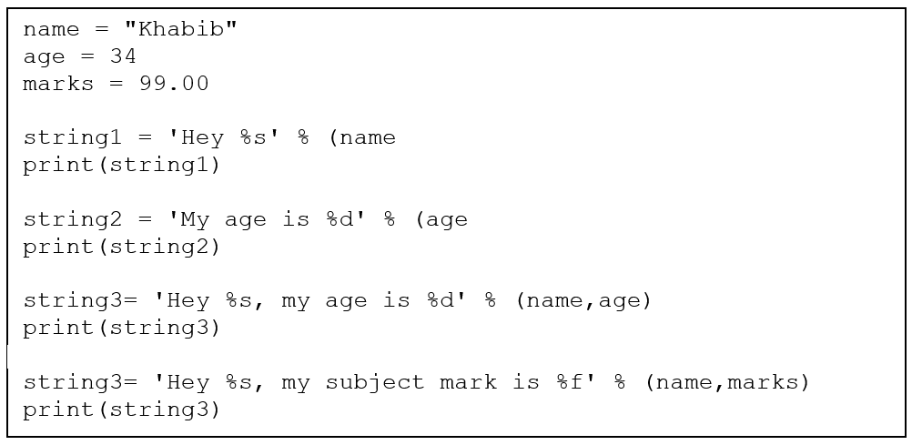

**Step 2:**  Save, compile and run the program. Save the program as Act2C.py. Observe the output.

**Output:**

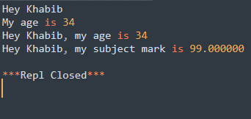

**Activity 2D**

Activity Outcome : String Operators

Procedures:

**Step 1:** Open code editor and type the following code:

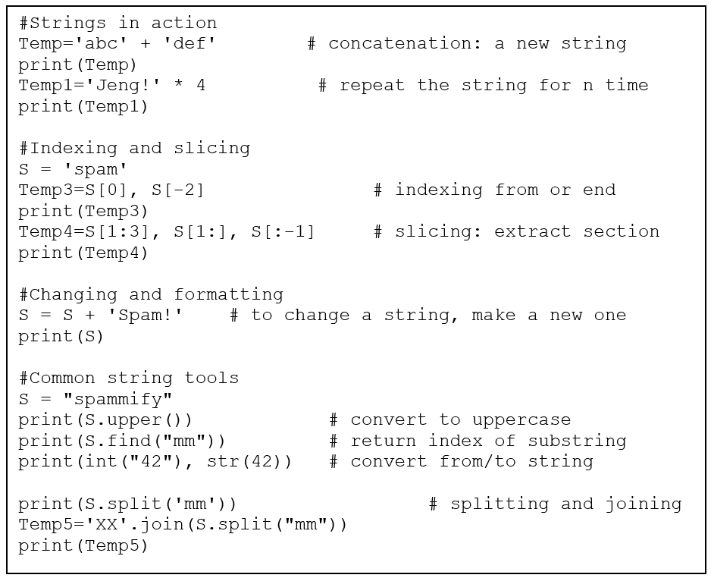

**Step 2:**  Save, compile and run the program. Save the program as Act2D.py. Write the output in the area below.

**Output:**

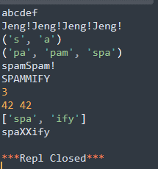

**Activity 2E**

Activity Outcome : Manipulate Python literals using converting operation

Procedures:

**Step 1:** Open code editor and type the following code:

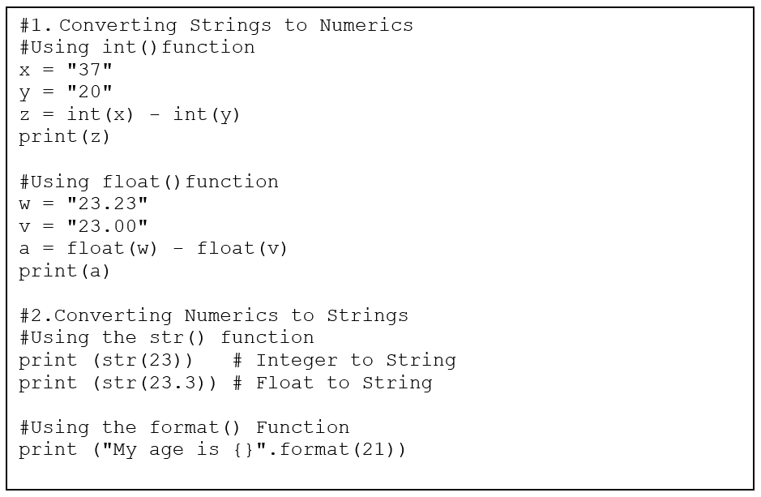

**Step 2:**  Save, compile and run the program. Save the program as Act2E.py. Write the output in the area below.

**Output:**

